January 21, 2022

Bernadette Q. Delector

Visca, Baybay City, Leyte

[delectorbernadette@gmail.com](mailto:delectorbernadette@gmail.com)

Ma’am/Sir:

Good day, I am hoping to be hired to experience and to practice my skills that I have learned and gained in my Bachelor Degree. I am physically fit and able to work in all types of field.

I will be honored if you will give me the opportunity to discuss the details with you along with my qualifications relevant to the job. For more additional details regarding to my qualification, please review my attached resume.

I am willing to wait for your call anytime which is more convenient for you. Please contact me thru email at [delectorbernadette@gmail.com](mailto:delectorbernadette@gmail.com) or in my contact number 09465162811.

I am hoping for your kind consideration. Thank you!

Respectfully:

Bernadette Delector

Applicant

**BERNADETTE QUINLOG DELECTOR**

VISCA, BAYBAY CITY, LEYTE

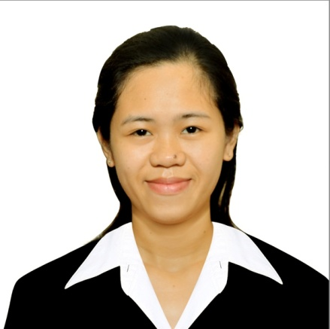

* MOBILE NO. 09465162811/ 09551791229
* EMAIL: delectorbernadette@gmail.com

**PERSONAL OBJECTIVES**

***Objectives*:** A competitive, organized and hard-working individual looking for a job which will help me to practice and developed my skills gained in my Bachelor degree in Visayas State University.

**PERSONAL BACKGROUND**

Birthday: November 04, 1998

Citizenship: Filipino

Age: 23

Religion: Roman Catholic

Sex: Female

Civil Status: Single

Name of Father: Roberto M. Delector

Name of Mother: Zenalyn Q. Delector

**EDUCATION BACKGROUND**

**Tertiary:**

Viasayas State University

Bachelor of Animal Science

S.Y. 2015 – 2019

**Secondary:**

Palo National High School

S.Y. 2011 – 2015

**Elementary:**

Alicia Central Elementary School

S.Y. 2002 – 2011

**Experience:**

* Field practice: Farrowing to Fattening Management of Swine at Panda Farm and Agricultural Corporation located in Barrio Cupang, Pandi, Bulacan

**SKILLS**

* Microsoft Office ( MS Word, Powerpoint and Excel)
* Excellent in communication and writing skills

**INTERPERSONAL TRAITS AND CHARACTERISTICS**

* Kind
* Hardworking
* Competitive
* Patient
* Honest
* Trustworthy
* Versatile
* Approachable

**LANGUAGES AND DIALECTS**

* English
* Tagalog
* Bisaya
* Waray-waray

**CHARACTER AND REFERENCES**

* **DR. JULIUS V. ABELA**

Department Head of Animal Science and Instructor

Visayas State University

* **EUGENE CHUA**

Farm Owner

Panda Farm and Agricultural Corporation at Barrio Cupang, Pandi, Bulacan

* **CYRILL P. GODINEZ**

Field Practice Coordinator

Visayas State University